SECTION 1: Hands-On Demonstration

Part 1. Edit Domain-Level Group Policy Objects (GPO)

1. the first policy change you made (screen capture):

2. the second policy change you made (screen capture):

3. the third policy change you made (screen capture):

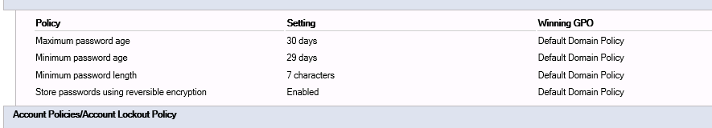

1. an explanation for the policy change you made;

First policy change: In observation summary.

Second policy change: In observation summary.

Third policy change: In observation summary.

1. the Suggested Value pop-up window for any policy for which it appears:

When I changed maximum password age, it changed minimum password age.

1. an explanation for why the Group Policy Management Editor recommended those changes:

The system doesn’t want minimum password age to be longer than maximum password age.

Part 2. Documenting and Auditing Group Policy

1. at least one of the policy changes you made, documented in the RSOP report (screen capture):



2. a comparison of the GPO Report and the RSOP Report: GPO report only shows the minimum password length policy while RSOP shows all.

SECTION 2: Applied Learning

Part 1: Edit Domain-Level Group Policy Objects (GPO)

1. the existing default domain password policy (screen capture):

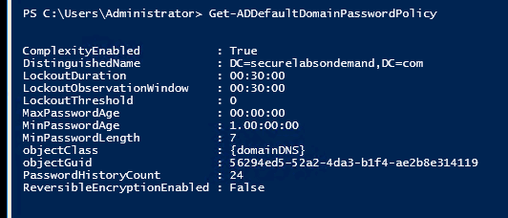

2. modified default domain password policy (screen capture):

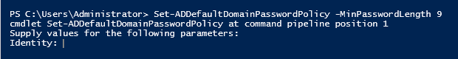

3. the PowerShell command to make the changes:



4. final default domain password policy (screen capture):

Part 2: Documenting and Auditing Group Policy

1. the command you used to generate the report:

2. final password policy changes (screen capture):

SECTION 3: Observation Summary

Write a 150 word summary to explain your understandings and findings from this lab assignment.

We RDP into machine1. We open the server manager. We go to group policy management. We then set a minimum password length policy with the value 7. This will force the passwords to be above a certain strength. We also enabled the policy for storing passwords using reversible encryption. This will keep the passwords safe even if they are stolen. And we set the maximum password age to 30 days. Which automatically set minimum password age to 29 days. This will force the users to change their password regularly and protect them from attacks that use old data.

We export policy change reports and look at them. We then put these files to the windows clipboard of the remote machine and then paste them to the dekstop of our local machine. Then we drag them into the file tranfer folder to downlaod them.

Wereset the lab and connect to remote machine.Weset values to the parameters to change settings.